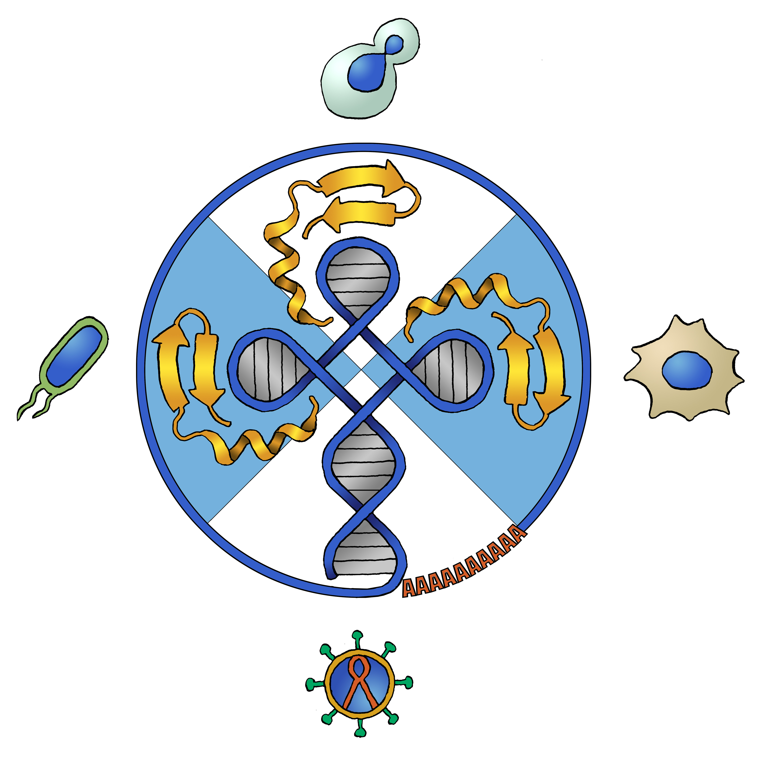

Postdoctoral position in the

Torben Heick Jensen lab.,
Aarhus University, Denmark

Mammalian nuclear RNA
turnover systems

A postdoctoral position is available in the laboratory of Torben Heick Jensen at the Department of Molecular Biology and Genetics, Aarhus University, Denmark. We are looking for a candidate with an interest in the biogenesis and turnover of nuclear RNA and its relationship to gene expression regulation in mouse embryonic stem cells and/or human cells. The Jensen laboratory consists of a dynamic mix of experimental and computational biologists aiming to examine the production, turnover and possible functional impact of eukaryotic transcriptomes. Candidates trained in biochemistry and/or cell biology are encouraged to apply.

The position is for two years with possible extension. Tax deduction benefits are available for non-Danish individuals. To apply submit letter of motivation, CV and 3 references before Sept 1st 2019.

For further information contact:

Professor Torben Heick Jensen, Department of Molecular Biology and Genetics, Aarhus University, C.F. Møllers Alle, Bldg. 1130, DK-8000 Aarhus C, Denmark, Tel.: +45 6020 2705, e-mail thj@mbg.au.dk

