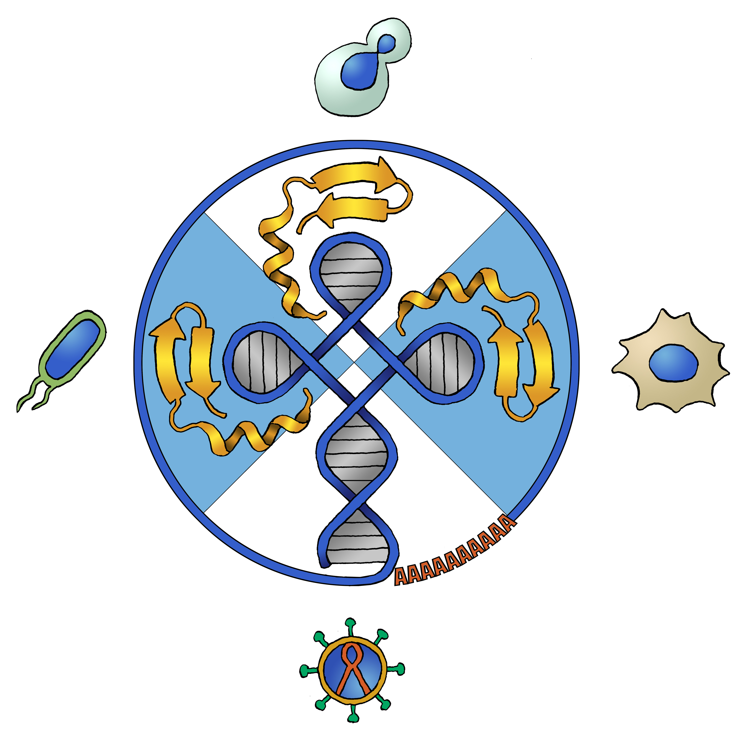

A postdoc position in the

Torben Heick Jensen lab.,
Aarhus University, Denmark

Mammalian nuclear RNA
turnover systems

A postdoc position is available in the laboratory of Torben Heick Jensen at the Department of Molecular Biology and Genetics, Aarhus University, Denmark. We are looking for a candidate with an interest in the biogenesis and turnover of nuclear RNA and its relationship to gene expression regulation in mammalian cells. The Jensen laboratory consists of a dynamic mix of experimental and computational biologists aiming to examine the production, turnover and possible functional impact of eukaryotic transcriptomes. Candidates trained in biochemistry, cell biology or genomics are encouraged to apply.

Tax deduction benefits are available for non-Danish individuals. To apply submit letter of motivation and CV before March 1st 2022.

For further information contact:

Professor Torben Heick Jensen, Department of Molecular Biology and Genetics, Aarhus University, C.F. Møllers Alle, Bldg. 1130, DK-8000 Aarhus C, Denmark, Tel.: +45 6020 2705, e-mail thj@mbg.au.dk

